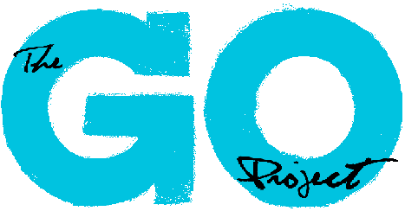
Children’s Curriculum Writer – Role Description

Position Title: Children’s Curriculum Writer

Outcome: To provide support for the curriculum design efforts of The GO Project through designing and writing the upcoming years curriculum content, promoting, and gaining new subscribers, thinking creatively and innovatively about the implementation of curriculum programs. Assist in the curriculum design needs of GO to help promote and pursue the mission/vision of The GO Project.

Key Responsibilities:
The Children’s Curriculum Writer duties may include but are not limited to:
- Assist in the development of a year-round curriculum program: a resource that offers a year’s worth (52 weeks) of Sunday School curriculum for communities of faith across the country based on Biblical stories
- Work effectively and in collaboration with the curriculum writing team to plan a year’s worth of content, delegate tasks, and implement the project
- Creatively think of ways to engage children in learning and exploring their faith through: story, games, crafts, theatre, outreach, and more
- To ensure all resources coming from The GO Project meet our messaging, mission, and theology
- Management of multiple projects with varied deadlines
- Represent The GO Project in a professional capacity with various groups
- Liaise with The GO Project staff, and board member as needed
- Other curriculum support duties as assigned

Accountability:
- This position reports to the Minister of The GO Project
- Additionally various GO Project staff and Board members will provide supervision and oversight for this role as needed

Length of Assignment: July 4th, 2022 – August 26th, 2022

Time Commitment: 35 hours per week

Working hours for this position will be remote, with the expectation that the successful candidate will be able to attend virtual meetings as needed.

Qualifications:
- Advanced education or training in curriculum design or education
- Familiarity with The United Church of Canada considered an asset
- Previous experience within program design and church program work
- Excellent professional communication skills, both written and verbal
- Ability to prioritize tasks under pressure
- Competency in Microsoft, Canva, or other design softwares
- Ability to work collaboratively on teams and with a wide range of individuals through various means of communication (email, phone, in person, etc.)
- Personally accountable, ability to work independently and with limited direct supervision

Orientation: On the first day of employment, the Children’s Curriculum Writer will be given a virtual orientation to The GO Project, introductions to various staff members and overview of the mission and vision of GO.

Training: Training will be provided during paid hours. This training will include those detailed in the GO Project annual policies and procedures handbook, relevant safety training and review of The GO Project standards and expectations.

Boundaries of the Position:
- Act professionally, responsibility and in accordance with The GO Project staff procedures handbook
- The Children’s Curriculum Writer will not disclose any confidential information related to the work of The GO Project, its community partners, staff or participants

