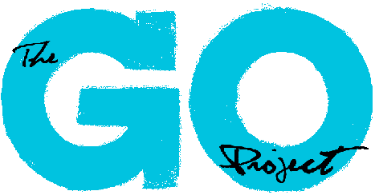
Multimedia Designer & Animation Assistant – Role Description

Position Title: Multimedia Designer & Animation Assistant

Outcome: To provide graphic animation support for the curriculum design efforts of The GO Project through animating cartoons and videos, and production design of curriculum. Assist in the curriculum graphic and animation design needs of GO to help promote and pursue the mission/vision of The GO Project.

Key Responsibilities:
The Multimedia Designer & Animation Assistant duties may include but are not limited to:
- Create graphic and video content that animates GO’s Sunday School and Youth Group curriculum for communities of faith across the country based on Biblical stories
- Work with our cartoon creating software (Moovly) to produce short engaging cartoon videos of Biblical and curriculum story themes
- Write, record, and delegate the production of video lessons
- Work effectively and in collaboration with the curriculum writing team to plan a year’s worth of content, delegate tasks, and implement the project
- Creatively think of ways to engage children & teens in learning and exploring their faith through: story, games, crafts, theatre, outreach, and more
- To ensure all resources coming from The GO Project meet our messaging, mission, and theology
- Management of multiple projects with varied deadlines
- Represent The GO Project in a professional capacity with various groups
- Liaise with The GO Project staff, and board member as needed
- Other curriculum support duties as assigned

Accountability:
- This position reports to the Minister of The GO Project
- Additionally various GO Project staff and Board members will provide supervision and oversight for this role as needed

Length of Assignment: July 4th, 2022 – August 26th, 2022

Time Commitment: 35 hours per week

Working hours for this position will be remote, with the expectation that the successful candidate will be able to attend virtual meetings as needed.

Qualifications:
- Advanced education or training in graphic design and video editing
- Familiarity with The United Church of Canada considered an asset
- Previous experience within program design and church program work
- Excellent professional communication skills, both written and verbal
- Ability to prioritize tasks under pressure
- Competency in Microsoft, Canva, or other design and video editing software’s
- Ability to work collaboratively on teams and with a wide range of individuals through various means of communication (email, phone, in person, etc.)
- Personally accountable, ability to work independently and with limited direct supervision

Orientation: On the first day of employment, the Multimedia Designer & Animation Assistant
will be given a virtual orientation to The GO Project, introductions to various staff members and overview of the mission and vision of GO.

Training: Training will be provided during paid hours. This training will include those detailed in the GO Project annual policies and procedures handbook, relevant safety training and review of The GO Project standards and expectations.

Boundaries of the Position:
- Act professionally, responsibility and in accordance with The GO Project staff procedures handbook
- The Multimedia Designer & Animation Assistant will not disclose any confidential information related to the work of The GO Project, its community partners, staff or participants

