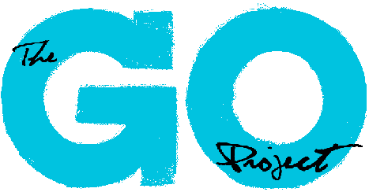
Curriculum Writing Coordinator – Role Description

Position Title: Curriculum Writing Coordinator

Outcome: To provide program support for the program efforts of The GO Project through coordinating the whole curriculum writing and design team. This position will supervise a team of up to five staff; delegating tasks and work to meet goals of program. Assist in the program design needs of GO to help promote and pursue the mission/vision of The GO Project.

Key Responsibilities:
The Curriculum Writing Coordinator duties may include but are not limited to:
- Plan, in consultation with the Minister to The GO Project, the 2024-2025 school year curriculum themes and prepare all necessary prep work for the curriculum writing team to begin their work
- Lead weekly team meetings, offer feedback daily, and ensure all lessons are consistent with GO’s pedagogy and theology
- Write, record, and delegate the production of video lessons
- Implement a program curriculum that is age appropriate for use with children and young teens in grades 2-7
- Creatively think of ways to engage children & teens in learning and exploring their faith through: story, games, crafts, theatre, outreach, and more
- Management of multiple projects with varied deadlines
- Represent The GO Project in a professional capacity with various groups
- Liaise with The GO Project staff, and board member as needed
- Other program support duties as assigned

Accountability:
- This position reports to the Minister of The GO Project
- Additionally various GO Project staff and Board members will provide supervision and oversight for this role as needed

Length of Assignment: June 24th – August 23rd, 2024

Time Commitment: 35 hours per week

Working hours for this position will be remote, with the expectation that the successful candidate will be able to attend virtual meetings as needed.

Qualifications:
- Advanced education or training in education and child and youth work
- Familiarity with The United Church of Canada considered an asset
- Previous experience within program design and church program work
- Excellent professional communication skills, both written and verbal
- Ability to prioritize tasks under pressure
- Competency in Microsoft
- Ability to work collaboratively on teams and with a wide range of individuals through various means of communication (email, phone, in person, etc.)
- Personally accountable, ability to work independently and with limited direct supervision

Orientation: On the first day of employment, the Curriculum Writing Coordinator
will be given a virtual orientation to The GO Project, introductions to various staff members and overview of the mission and vision of GO.

Training: Training will be provided during paid hours. This training will include those detailed in the GO Project annual policies and procedures handbook, relevant safety training and review of The GO Project standards and expectations.

Boundaries of the Position:
- Act professionally, responsibility and in accordance with The GO Project staff procedures handbook
- The Curriculum Writing Coordinator will not disclose any confidential information related to the work of The GO Project, its community partners, staff or participants

Send your cover letter and resume to alana@thegoproject.ca by May 10th, 2024.

