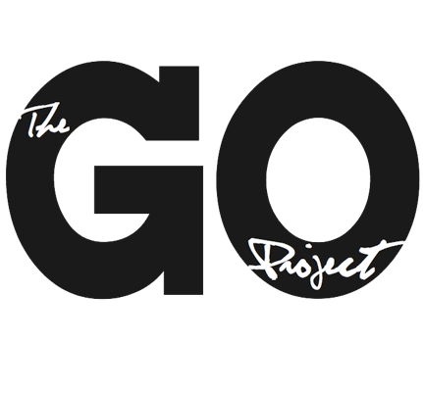

The GO Project

108 John St.
Bracebridge, ON P1L 1R8
admin@thegoproject.ca
www.thegoproject.ca

Position: Administrative Assistant (Summer Student – 8 Weeks)
Reports to: Minister to The GO Project

Role of this Position
- To support The GO Project’s administrative, operational, and product development needs
- To ensure curriculum resources are polished, organized, and ready for distribution
- To strengthen internal systems and prepare key organizational initiatives
- To support leadership of the GO Beyond: Youth Summer Program July 18th – 26th in Orleans, Ontario

Responsibilities
The Administrative Assistant will:
- Edit and format curriculum resources, including:
  - New lessons created during the summer
  - Existing backlog (Special Sundays & VBS)
  - CHURCHx course descriptions (adding weeks, resource lists, clarity)
- Create bundled curriculum packages (e.g., Life & Ministry of Jesus, Prophets, Biggest Hits)
- Support summer program registration processes and tracking
- Assist with Affirming Process preparation, including:
  - Policy review
  - Inclusive language updates
  - Documentation preparation for congregational voting
- Support general administrative needs (file organization, data entry, communications support)
- Offer website edit suggestions, and if skilled, implement edits approved by Minister
- To support the GO Beyond Youth Coordinator with leadership needs during the duration of the youth program

Measurable Outcomes
- 100% of new curriculum lessons edited, formatted, and publication-ready
- Minimum 10 backlog resources updated and standardized
- 3–5 curriculum bundles created and prepared for sale
- All CHURCHx product descriptions updated to include number of weeks and resource lists
- Summer program registration system fully organized and tracked (0 missing participant data)
- Affirming Process documentation prepared (policies reviewed, inclusive language updates drafted)

Qualifications
- Strong organizational and administrative skills
- High attention to detail (especially editing and formatting)
- Ability to manage multiple projects simultaneously
- Strong written communication skills
- Experience with Microsoft Office / Google Workspace / Canva
- Interest in nonprofit, ministry, or organizational operations
This is an 8-week contract, dates are flexible based on candidates availability. Ideally, all curriculum is finished and ready for publication by early-mid August.

Terms: 35 hours per week, $20 per hour.

To apply, send your resume and cover letter to alana@thegoproject.ca by May 8th, 2026

