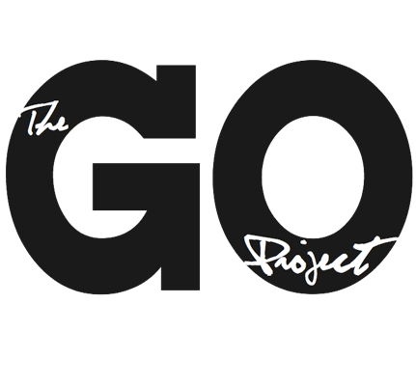

The GO Project

108 John St.
Bracebridge, ON P1L 1R8
admin@thegoproject.ca
www.thegoproject.ca

Position: Curriculum Writer (Summer Student – 8 Weeks)
Reports to: Minister to The GO Project

Role of this Position
- To support The GO Project’s curriculum development priorities through the creation of high-quality, engaging, and theologically grounded lessons
- To contribute to GO Project’s strategic shift toward flexible, theme-based curriculum offerings
- To support leadership of the GO Beyond: Youth Summer Program July 18th – 26th in Orleans, Ontario

Responsibilities
The Curriculum Writer will:
- Develop 6 new curriculum lessons
- Follow GO Project curriculum templates and pedagogy
- Ensure content is age-appropriate, engaging, and aligned with GO Project values (inclusion, justice, creativity, faith exploration)
- Revise and finalize content based on feedback
- Collaborate with the Administrative Assistant on edits and final formatting
- To support the GO Beyond Youth Coordinator with leadership needs during the duration of the youth program

Measurable Outcomes
- 6 fully written, edited, and publication-ready lessons completed
- 100% of lessons formatted according to GO templates and ready for upload to CHURCHx
- At least 2 rounds of revisions completed per lesson based on supervisor feedback
- Content designed for flexibility (minimum 2 age adaptations or activity options per lesson)

Qualifications
- Strong writing and editing skills
- Experience working with children and/or youth (church, camp, education, etc.)
- Ability to translate complex ideas into accessible, engaging content
- Interest in faith formation, curriculum design, or education
- Familiarity with Christian scripture and themes (United Church context an asset)
- Ability to work independently and meet deadlines
This is an 8-week contract, dates are flexible based on candidates availability. Ideally, all curriculum is finished and ready for publication by early-mid August.

Terms: 35 hours per week, $20 per hour.

To apply, send your resume and cover letter to alana@thegoproject.ca by May 8th, 2026

