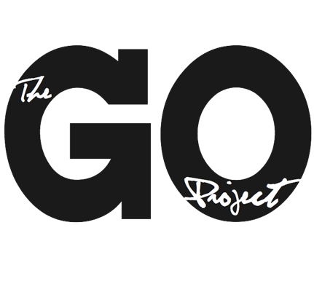

The GO Project

108 John St.
Bracebridge, ON P1L 1R8
admin@thegoproject.ca
www.thegoproject.ca

Position: GO Grow Program Assistant (Summer Student – 8 Weeks)
Reports to: Minister to The GO Project

Role of this Position
- To support the development and implementation of the GO Grow program (audits and workshops)
- To help translate research, data, and pilot learnings into a sustainable and scalable program model
- To strengthen GO Project’s leadership development and consulting capacity
- To support leadership of the GO Beyond: Youth Summer Program July 18th – 26th in Orleans, Ontario

Responsibilities
The GO Grow Program Assistant will:
- Compile and synthesize research, including:
  - Previous GO Grow surveys and data
  - Workshop materials and recordings
  - Insights from pilot communities
- Support the development of a clear GO Grow model, including:
  - Pricing structure
  - Time requirements
  - Reporting templates and deliverables
- Assist in updating the website to reflect:
  - GO Grow framework
  - Rubric and evaluation tools
  - Six core strength identities
- Upload and organize workshop recordings on CHURCHx for asynchronous learning
- Support development of the GO Lead course on CHURCHx
- If aligned with skills, assist in creating resources such as:
  - Intergenerational service outlines
  - Pew cards
  - Children’s sermons
  - Additional resources gleaned from GO Grow findings and data
- To support the GO Beyond Youth Coordinator with leadership needs during the duration of the youth program

Measurable Outcomes
- 1 comprehensive GO Grow program framework document completed (including pricing, process, and reporting templates)
- Research from 3 pilot communities synthesized into actionable insights
- Website updated with GO Grow overview, rubric, and 6 strength identities
- 4 workshop recordings uploaded and organized on CHURCHx
- Foundational structure for GO Lead course completed (outline + at least 2 modules drafted)
- At least 2 new practical ministry resources developed (if applicable)

Qualifications
- Strong research, synthesis, and analytical skills
- Ability to translate ideas into clear, practical tools and frameworks
- Strong writing and organizational skills
- Interest in leadership development, ministry innovation, or program design
- Experience with data organization or qualitative analysis an asset
- Self-motivated and able to work independently
This is an 8-week contract, dates are flexible based on candidates availability. Ideally, all curriculum is finished and ready for publication by early-mid August.

Terms: 35 hours per week, $20 per hour.

To apply, send your resume and cover letter to alana@thegoproject.ca by May 8th, 2026

