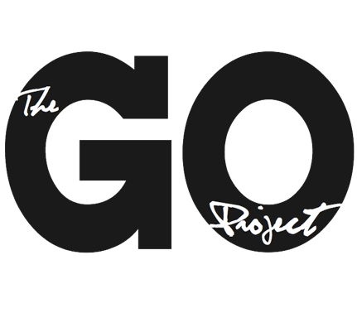

The GO Project

108 John St.
Bracebridge, ON P1L 1R8
admin@thegoproject.ca
www.thegoproject.ca

GO Beyond: Youth Program Coordinator
Summer 2026

The Youth Program Coordinator will oversee the operation of a local youth service program hosted at Orléans United Church, supporting its implementation on and off-site. They will collaborate with Minister to The GO Project, Rev. Molly Bell (Orléans United Church,) and other local partners to ensure the program’s success, aligning it with the values and goals of the United Church of Canada. This position will be based in Orléans , Ontario.

Responsibilities
The Youth Program Coordinator will:
- Run all program pieces and logistics for GO Beyond: July 18th – 26th, 2026
- Supervise the use of the church building and resources, ensuring responsible use and care.
- Model and teach United Church of Canada values related to faith development, community building, and social justice.
- Provide leadership, mentorship, and resource support to staff, volunteers, and youth participants.
- Collaborate with Orléans United Church and partner organization, The GO Project, to develop a curriculum and program plan that reflects the unique needs of the local community.
- Facilitate food justice initiatives, including creating menus, organizing food preparation teams, and leading workshops on food sovereignty.
- Build relationships with participants, church members, and local community organizations to foster engagement and support.

Typical Duties
- Reach out to potential service sites and schedule the groups’ activities.
- Plan the 8-days of programming including service sites, menu, workshops, leisure activities, and worship.
- Communicate with potential participants and families to encourage program registration.
- Distribute information, forms, and updates to participants.
- Promote the program through presentations, media releases, and community outreach.
- Plan and implement daily program activities in collaboration with staff and volunteers.
- Ensure the safety and well-being of all participants by following and implementing safety protocols, including fire safety and first aid.
- Collaborate regularly with Orléans United Church and The GO Project leadership through meetings and check-ins.
- Recruit, train, and supervise local volunteers to support the program’s operation.
- Develop a debriefing process for participants and staff, including evaluations to improve future programming.
- Create a year-end report for church leadership and grant funders, summarizing program outcomes and recommendations.

Qualifications
- Minimum 4 years of leadership experience in a Christian context.
- At least 2 years of experience in resource planning and program delivery within a faith-based setting.
- Proven experience working with youth in mission-focused programming.
- Training and experience in group facilitation, conflict resolution, and communication skills.
- Experience responding to emergency situations and disclosures of abuse, with appropriate training.
- Food Safety Training (certification will be provided if needed).
- Must meet Canada Summer Job eligibility: be between the ages of 20-30 and legally allowed to work in Canada.

Skills and Abilities
- Strong leadership and mentoring skills, with experience supervising staff or volunteers.
- Knowledge of biblical and theological concepts, with the ability to integrate these into program activities.
- Effective team-building and conflict-resolution skills.
- Excellent organizational skills, with attention to detail and the ability to manage multiple priorities.
- Comfort leading in a Christian environment and providing pastoral care to youth and staff.
- Ability to maintain confidentiality and handle sensitive situations with care.
Summer Schedule:
June 8th – 12th: Staff Orientation & Training
June 15th – July 17th: Program Prep
July 18th – 26th: Program
July 27th – 31st: Evaluation & Debrief
Employment: 8 weeks, 35 hours per week, at $25 per hour. June 8th – July 31st, 2026
To apply: Send your resume and cover letter to alana@thegoproject.ca by May 5th, 2026

