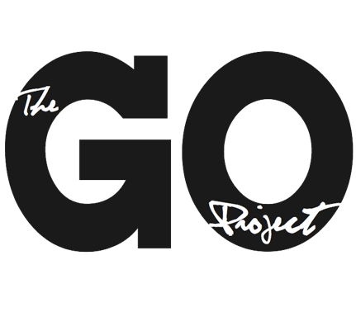

The GO Project

108 John St.
Bracebridge, ON P1L 1R8
admin@thegoproject.ca
www.thegoproject.ca

Position: Social Media & Storyteller Intern (Summer Student – 8 Weeks, 2 Positions – High School Students)
Reports to: Minister to The GO Project

Role of this Position
- To amplify The GO Project’s voice through creative storytelling and digital content
- To engage younger generations through relevant and compelling media
- To support promotional and communications efforts across GO Project platforms

Responsibilities
The Social Media & Storyteller Intern will:
- Create social media content, including:
  - Short-form videos
  - Promotional posts
  - Storytelling content highlighting GO programs and impact
- Design promotional materials such as:
  - Slide decks
  - Flyers
  - Updated pamphlets
- Participate in GO Beyond (July 18th – 26th in Orleans Ontario) and Collective (August 12th – 15th in St. Catharine’s) programs and share lived experiences through content
- Suggest updates and improvements to the GO Project website (implemented by staff)
- Participate in weekly in-person skill-building and leadership development sessions
- Collaborate with team members to ensure content aligns with GO Project messaging and values

Measurable Outcomes
- Minimum 3–4 social media posts per week (per intern or collaboratively)
- At least 10 short-form videos created over the summer
- 1 updated promotional pamphlet and 1 standardized slide deck completed
- Content produced for 100% of GO Beyond & Collective participation days
- At least 5 actionable website improvement recommendations submitted
- Demonstrated skill growth (self-assessment + supervisor feedback at mid and end point)

Qualifications
- Current high school student
- Interest in social media, storytelling, or creative content creation
- Basic skills in video editing, design, or digital tools (or willingness to learn)
- Strong communication and creativity
- Ability to work both independently and collaboratively
- Interest in faith, community, or youth engagement is an asset
Terms: July 6th – August 28th, 2026, 35 hours per week, $20 per hour.

To apply, send your resume and cover letter to alana@thegoproject.ca by May 8th, 2026

